**Count**

**To count the number of cells that contain numbers, use the COUNT function.**

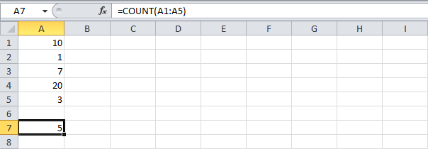

**Countif**

**To count cells based on one criteria (for example, higher than 9), use the following COUNTIF function.**

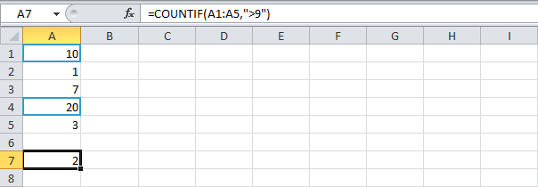

**Countifs**

**To count cells based on multiple criteria (for example, green and higher than 9), use the following COUNTIFS function.**

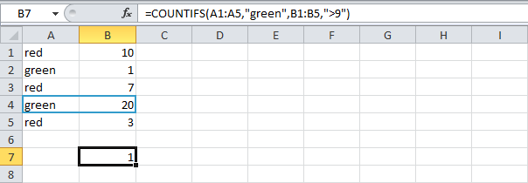

**Sum**

**To sum a range of cells, use the SUM function.**

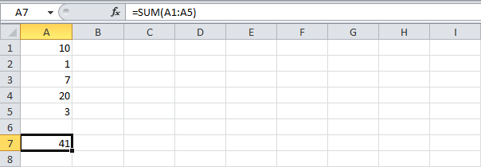

**Sumif**

**To sum cells based on one criteria (for example, higher than 9), use the following SUMIF function (two arguments).**

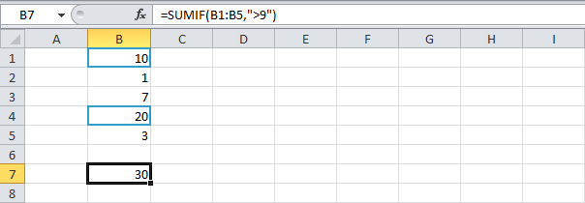

**To sum cells based on one criteria (for example, green), use the following SUMIF function (three arguments, last argument is the range to sum).**

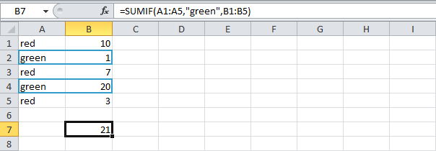

**Sumifs**

**To sum cells based on multiple criteria (for example, blue and green), use the following SUMIFS function (first argument is the range to sum).**

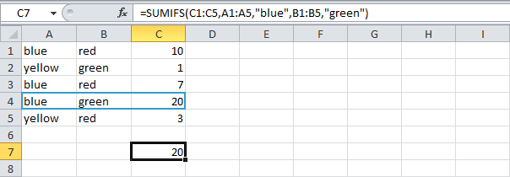

**General note: in a similar way, you can use the AVERAGEIF and AVERAGEIFS function to average cells based on one or multiple criteria.**

### If Function

**The IF function checks whether a condition is met, and returns one value if TRUE and another value if FALSE.**

**1. Select cell C2 and enter the following function.**

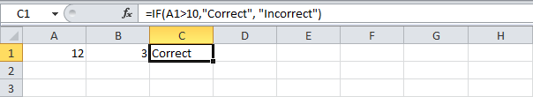

**The IF function returns Correct because the value in cell A1 is higher than 10.**

### And Function

**The AND Function returns TRUE if all conditions are true and returns FALSE if any of the conditions are false.**

**1. Select cell D2 and enter the following formula.**

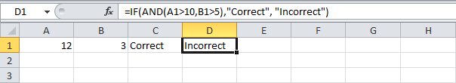

**The AND function returns FALSE because the value in cell B2 is not higher than 5. As a result the IF function returns Incorrect.**

### Or Function

**The OR function returns TRUE if any of the conditions are TRUE and returns FALSE if all conditions are false.**

**1. Select cell E2 and enter the following formula.**

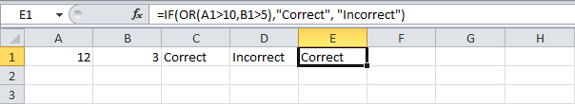

**The OR function returns TRUE because the value in cell A1 is higher than 10. As a result the IF function returns Correct.**

### Relative Reference

**By default, Excel uses relative reference. See the formula in cell D2 below. Cell D2 references (points to) cell B2 and cell C2. Both references are relative.**

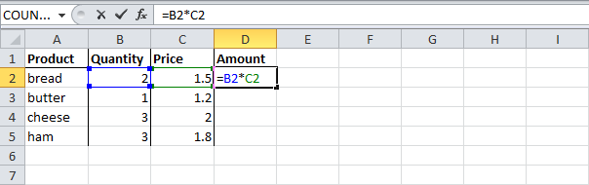

**1. Select cell D2, click on the lower right corner of cell D2 and**[**drag**](http://www.excel-easy.com/introduction/range.html#fill-range)**it down to cell D5.**

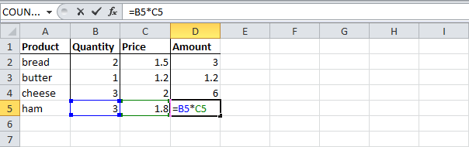

**Cell D3 references cell B3 and cell C3. Cell D4 references cell B4 and cell C4. Cell D5 references cell B5 and cell C5. In other words: each cell references its two neighbors on the left.**

### Absolute Reference

**See the formula in cell E3 below.**

**1. To create an absolute reference to cell H3, place a $ symbol in front of the column letter and row number of cell H3 ($H$3) in the formula of cell E3.**

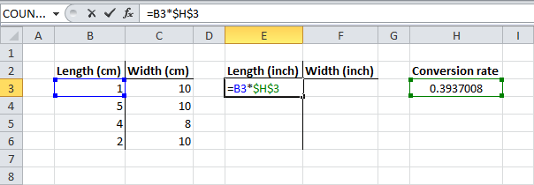

**2. Now we can quickly drag this formula to the other cells.**

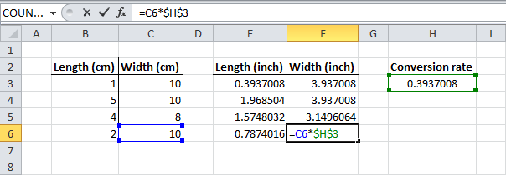

**The reference to cell H3 is fixed (when we drag the formula down and across). As a result, the correct lengths and widths in inches are calculated.**

### Mixed Reference

**Sometimes we need a combination of relative and absolute reference (mixed reference).**

**1. See the formula in cell F2 below.**

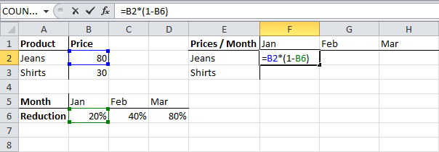

**2. We want to copy this formula to the other cells quickly. Drag cell F2 across one cell, and look at the formula in cell G2.**

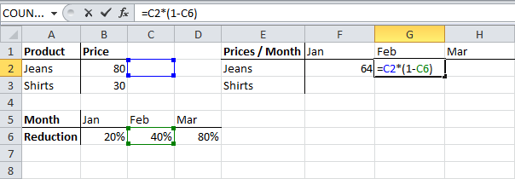

**Do you see what happens? The reference to the price should be a fixed reference to column B. Solution: place a $ symbol in front of the column letter of cell B2 ($B2) in the formula of cell F2. In a similar way, when we drag cell F2 down, the reference to the reduction should be a fixed reference to row 6. Solution: place a $ symbol in front of the row number of cell B6 (B$6) in the formula of cell F2.**

**Result:**

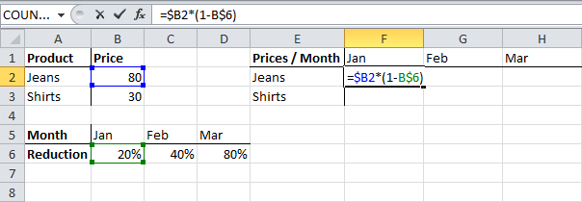

**Note: we don't place a $ symbol in front of the row number of B2 (this way we allow the reference to change from B2 (Jeans) to B3 (Shirts) when we drag the formula down). In a similar way, we don't place a $ symbol in front of the column letter of B6 (this way we allow the reference to change from B6 (Jan) to C6 (Feb) and D6 (Mar) when we drag the formula across).**

**3. Now we can quickly drag this formula to the other cells.**

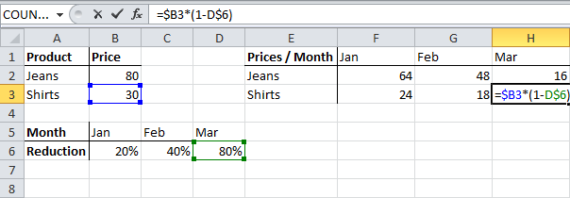

# Date & Time Functions

|  |
| --- |
|  |

[**Year, Month, Day**](http://www.excel-easy.com/functions/date-time-functions.html#year-month-day)**|**[**Date Function**](http://www.excel-easy.com/functions/date-time-functions.html#date-function)**|**[**Current Date & Time**](http://www.excel-easy.com/functions/date-time-functions.html#current-date-time)**|**[**Hour, Min, Sec**](http://www.excel-easy.com/functions/date-time-functions.html#hour-min-sec)**|**[**Time Function**](http://www.excel-easy.com/functions/date-time-functions.html#time-function)

**To enter a date in Excel, use the "/" or "-" characters. To enter a time, use the ":" (colon). You can also enter a date and a time in one cell.**

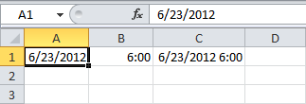

**Note: Dates are in US Format. Months first, Days second. This type of format depends on your windows regional settings. Learn more about**[**Date and Time formats**](http://www.excel-easy.com/examples/date-time-formats.html)**.**

### Year, Month, Day

**To get the year of a date, use the YEAR function.**

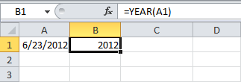

**Note: use the MONTH and DAY function to get the month and day of a date.**

### Date Function

**1. To add a number of days to a date, use the following simple formula.**

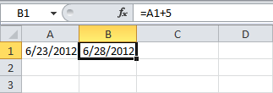

**2. To add a number of years, months and/or days, use the DATE function.**

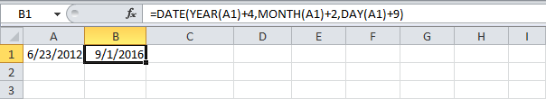

**Note: the DATE function accepts three arguments: year, month and day. Excel knows that 6 + 2 = 8 = August has 31 days and rolls over to the next month (23 August + 9 days = 1 September).**

### Current Date & Time

**To get the current date and time, use the NOW function.**

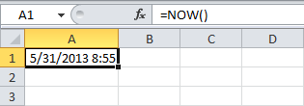

**Note: use the TODAY function to get the current date only. Use NOW()-TODAY() to get the current time only (and apply a**[**Time format**](http://www.excel-easy.com/examples/date-time-formats.html)**).**

### Hour, Min, Sec

**To return the hour, use the HOUR function.**

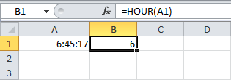

**Note: use the MINUTE and SECOND function to return the minute and second.**

### Time Function

**To add a number of hours, minutes and/or seconds, use the TIME function.**

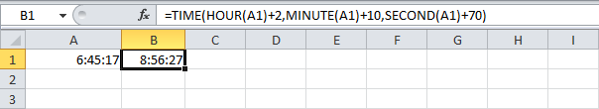

**Note: Excel adds 2 hours, 10 + 1 = 11 minutes and 70 - 60 = 10 seconds.**

# Text Functions

|  |
| --- |
|  |

[**Join Strings**](http://www.excel-easy.com/functions/text-functions.html#join-strings)**|**[**Left**](http://www.excel-easy.com/functions/text-functions.html#left)**|**[**Right**](http://www.excel-easy.com/functions/text-functions.html#right)**|**[**Mid**](http://www.excel-easy.com/functions/text-functions.html#mid)**|**[**Len**](http://www.excel-easy.com/functions/text-functions.html#len)**|**[**Find**](http://www.excel-easy.com/functions/text-functions.html#find)**|**[**Substitute**](http://www.excel-easy.com/functions/text-functions.html#substitute)

**Excel has many functions to offer when it comes to manipulating text strings.**

### Join Strings

**To join strings, use the & operator.**

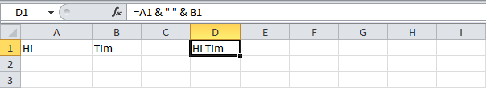

**Note: to insert a space, use " "**

### Left

**To extract the leftmost characters from a string, use the LEFT function.**

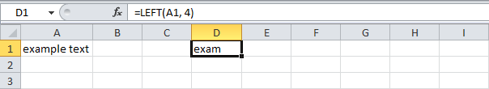

### Right

**To extract the rightmost characters from a string, use the RIGHT function.**

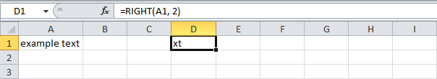

### Mid

**To extract a substring, starting in the middle of a string, use the MID function.**

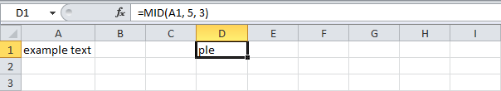

**Note: started at position 5 (p) with length 3.**

### Len

**To get the length of a string, use the LEN function.**

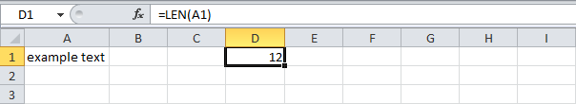

**Note: space (position 8) included!**

### Find

**To find the position of a substring in a string, use the FIND function.**

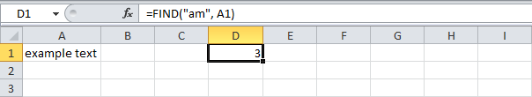

**Note: string "am" found at position 3.**

### Substitute

**To replace existing text with new text in a string, use the SUBSTITUTE function.**

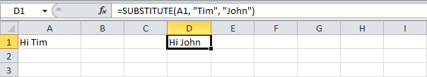

### VLookup

**The VLOOKUP (Vertical lookup) function looks for a value in the leftmost column of a table, and then returns a value in the same row from another column you specify.**

**1. Insert the VLOOKUP function shown below.**

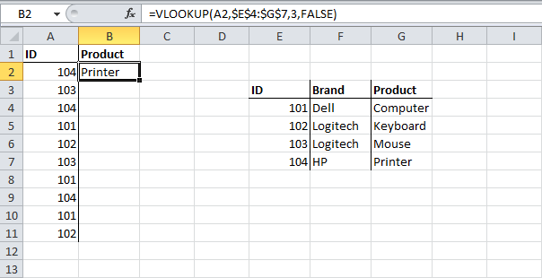

**Explanation: the VLOOKUP function looks for the ID (104) in the leftmost column of the range $E$4:$G$7 and returns the value in the same row from the third column (third argument is set to 3). The fourth argument is set to FALSE to return an exact match or a #N/A error if not found.**

**2. Drag the VLOOKUP function in cell B2 down to cell B11.**

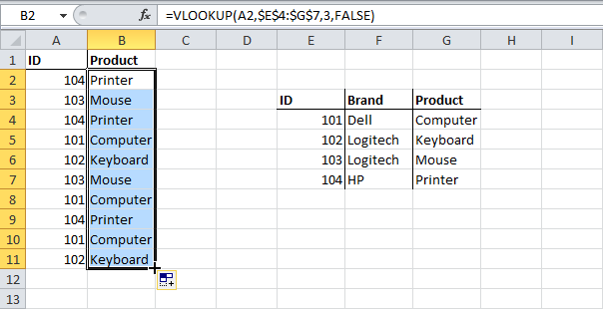

**Note: when we drag the VLOOKUP function down, the**[**absolute reference**](http://www.excel-easy.com/functions/cell-references.html#absolute-reference)**($E$4:$G$7) stays the same, while the relative reference (A2) changes to A3, A4, A5, etc.**

### HLookup

**In a similar way, you can use the HLOOKUP (Horizontal lookup) function.**

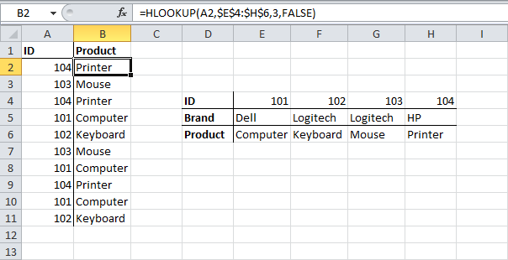

### Match

**The MATCH function returns the position of a value in a given range.**

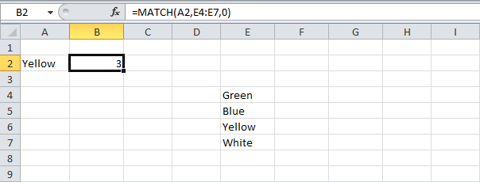

**Note: Yellow found at position 3 in the range E4:E7. The third argument is optional. Set this argument to 0 to return the position of the value that is exactly equal to lookup_value (A2) or a #N/A error if not found.**

### Index

**The INDEX function returns a specific value in a two-dimensional or one-dimensional range.**

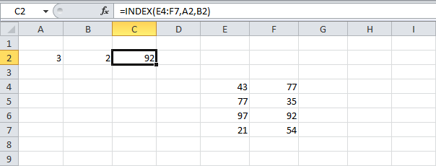

**Note: 92 found at the intersection of row 3 and column 2 in the range E4:F7.**

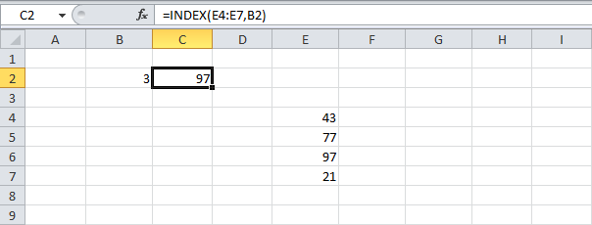

**Note: 97 found at position 3 in the range E4:E7.**

### Choose

**The CHOOSE function returns a value from a list of values, based on a position number.**

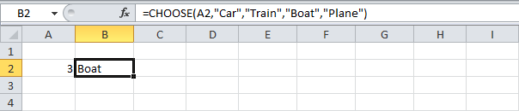

**Note: Boat found at position 3.**

### Pmt

**Select cell A2 and insert the PMT function.**

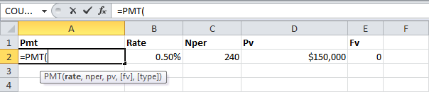

**Note: The last two arguments are optional. For loans the Fv can be omitted (the future value of a loan equals 0, however, it's included here for clarification). If Type is omitted, it is assumed that payments are due at the end of the period.**

**Result. The monthly payment equals $1,074.65.**

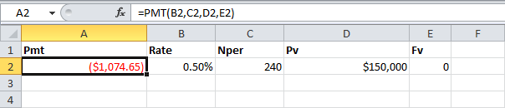

**Tip: when working with financial functions in Excel, always ask yourself the question, am I making a payment (negative) or am I receiving money (positive)? We pay off a loan of $150,000 (positive, we received that amount) and we make monthly payments of $1,074.65 (negative, we pay).**

### Rate

**If Rate is the only unknown variable, we can use the RATE function to calculate the interest rate.**

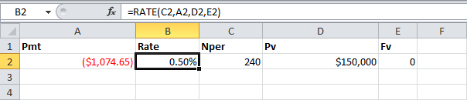

### Nper

**Or the NPER function. If we make monthly payments of $1,074.65 on a 20-year loan, with an annual interest rate of 6%, it takes 240 months to pay off this loan.**

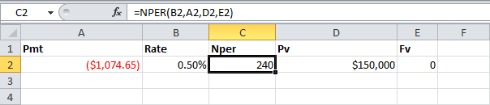

**We already knew this, but we can change the monthly payment now to see how this affects the total number of periods.**

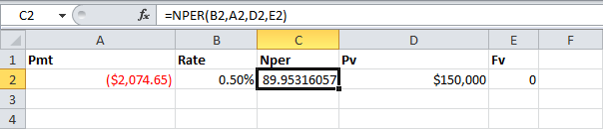

**Conclusion: if we make monthly payments of $2,074.65, it takes less than 90 months to pay off this loan.**

### Pv

**Or the PV (Present Value) function. If we make monthly payments of $1,074.65 on a 20-year loan, with an annual interest rate of 6%, how much can we borrow? You already know the answer.**

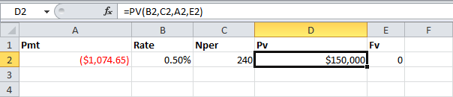

### Fv

**And we finish this chapter with the FV (Future Value) function. If we make monthly payments of $1,074.65 on a 20-year loan, with an annual interest rate of 6%, do we pay off this loan? Yes.**

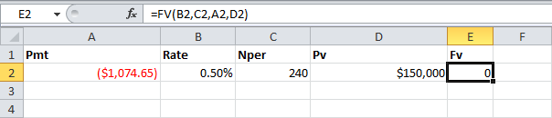

**But, if we make monthly payments of only $1,000.00, we still have debt after 20 years.**

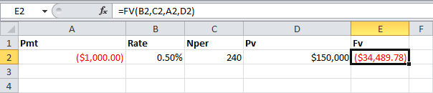

### Average

**To calculate the average of a range of cells, use the AVERAGE function.**

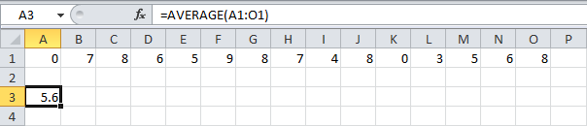

### Averageif

**To average cells based on one criteria, use the AVERAGEIF function. For example, to calculate the average excluding zeros.**

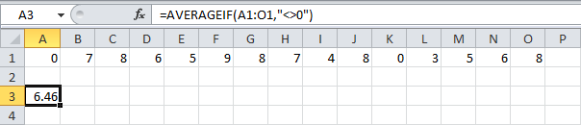

**Note: <> means not equal to. The AVERAGEIF function is similar to the**[**SUMIF**](http://www.excel-easy.com/functions/count-sum-functions.html#sumif)**function.**

### Median

**To find the median (or middle number), use the MEDIAN function.**

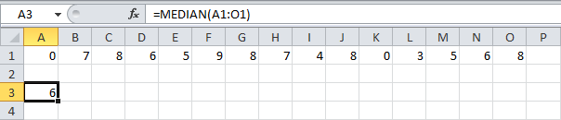

**Check:**

**Median Check**

### Mode

**To find the most frequently occurring number, use the MODE function.**

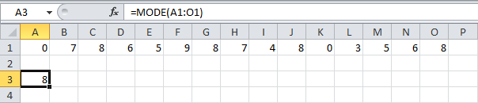

### Standard Deviation

**To calculate the standard deviation, use the STEDV function.**

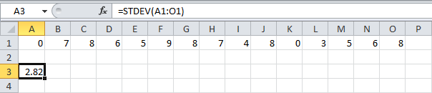

### Min

**To find the minimum value, use the MIN function.**

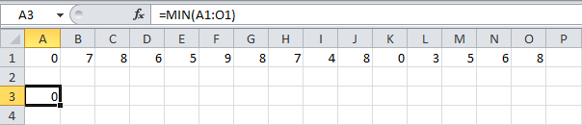

### Max

**To find the maximum value, use the MAX function.**

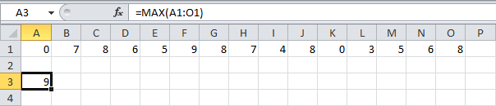

### Large

**To find the third largest number, use the following LARGE function.**

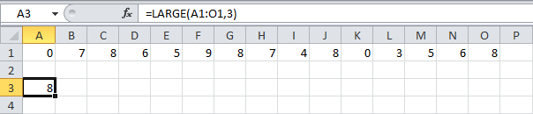

**Check:**

**Large Check**

### Small

**To find the second smallest number, use the following SMALL function.**

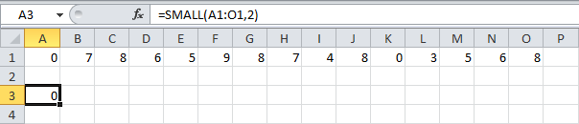

**Check:**

**Small Check**

**Tip: Excel can generate most of these results with the click of a button. Our**[**Descriptive Statistics**](http://www.excel-easy.com/examples/descriptive-statistics.html)**example shows you how.**

### Round

**1. Round a number to two decimal places.**

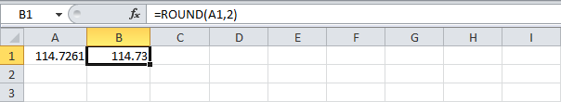

**Note: 1, 2, 3, and 4 get rounded down. 5, 6, 7, 8, and 9 get rounded up. In this example, 114.7211, 114.7221, 114.7231 and 114.7241 get rounded down to 114.72 and 114.7251, 114.7261, 114.7271, 114.7281 and 114.7291 get rounded up to 114.73.**

**2. Round a number to one decimal place.**

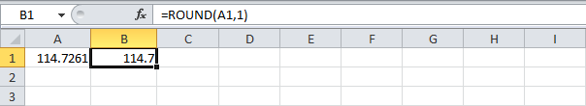

**3. Round a number to the nearest integer.**

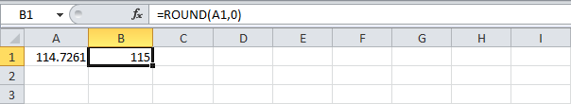

**4. Round a number to the nearest 10.**

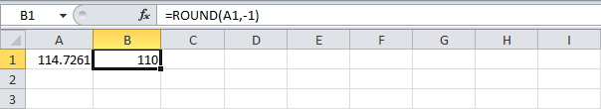

**5. Round a number to the nearest 100.**

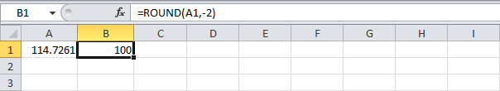

### RoundUp

**The ROUNDUP function always rounds a number up (away from zero). For example, round a number up to one decimal place.**

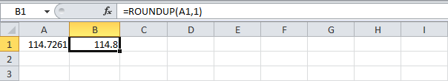

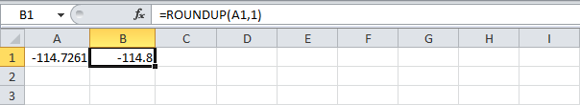

### RoundDown

**The ROUNDDOWN function always rounds a number down (toward zero). For example, round a number down to the nearest integer.**

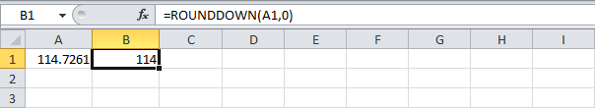

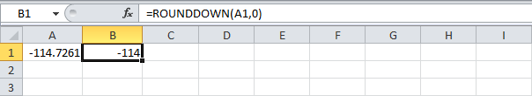

### ##### error

**When your cell contains this error code, the column isn't wide enough to display the value.**

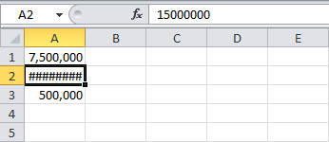

**1. Click on the right border of the column A header and increase the column width.**

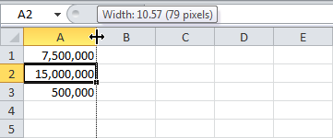

**Tip: double click the right border of the column A header to automatically fit the widest cell in column A.**

### #NAME? error

**The #NAME? error occurs when Excel does not recognize text in a formula.**

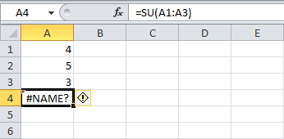

**1. Simply correct SU to SUM.**

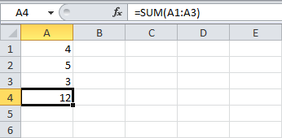

### #VALUE! error

**Excel displays the #VALUE! error when a formula has the wrong type of argument.**

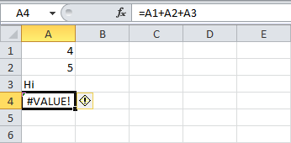

**1a. Change the value of cell A3 to a number.  
1b. Use a function to ignore cells that contain text.**

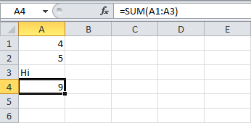

### #DIV/0! error

**Excel displays the #DIV/0! error when a formula tries to divide a number by 0 or an empty cell.**

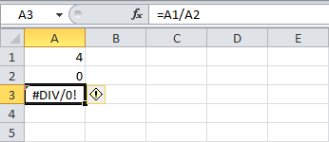

**1a. Change the value of cell A2 to a value that is not equal to 0.  
1b. Prevent the error from being displayed by using the logical function IF.**

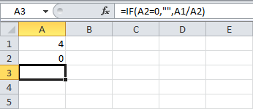

**Explanation: if cell A2 equals 0, an empty string is displayed. If not, the result of the formula A1/A2 is displayed.**

### #REF! error

**Excel displays the #REF! error when a formula refers to a cell that is not valid.**

**1. Cell C1 references cell A1 and cell B1.**

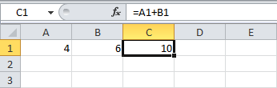

**2. Delete column B. To achieve this, right click the column B header and click Delete.**

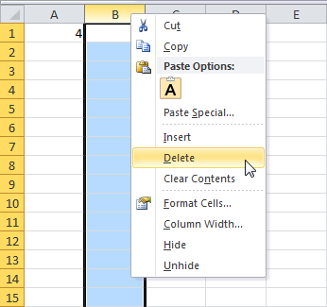

**3. Select cell B1. The reference to cell B1 is not valid anymore.**

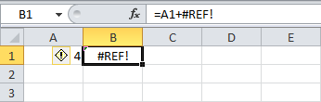

**4. To fix this error, you can either delete +#REF! in the formula of cell B1 or you can undo your action by clicking Undo in the Quick Access Toolbar (or press CTRL + z).**

